Who should use this document?
This document was designed for student researchers who are conducting exempt studies using medical records or specimens only.

What does this document contain?
This document contains tips for filling out the iStar IRB application and links to applicable supplemental materials.

Is this document applicable for all student research studies?
No. Please read all the iStar questions carefully when you are filling out your IRB application.

How should I start?
Please review the “Getting Started” page on the Human Research Protection Program website.

What other information should I have ready when I start the IRB application process?
- You should have a DHS employee ID for either yourself or your faculty advisor. (At a minimum, one investigator must have either an active “C” or “E” number with DHS).

- If you getting data from USC/Keck Clinical Data Warehouse, you will need “query ID number” for your iStar application.

- Please also have your protocol filled out and ready to be attached. You will find the USC Medical Records and Specimens ONLY Protocol on the HRPP website.

What do I do if I still have questions after I review all information?
Please send an email to hrpp@usc.edu.

Table of Contents
Create New Study 3
Section 1: Project Identification and Abstract 3
Section 2. Study Personnel 4
Section 2.2 & 2.5 5
Section 4: Funding 5
Section 5: Type of Study Review 6
Section 6: Study Locations 6
Section 9. Methods and Procedures 7
Section 13. Methods and Procedures 8
Section 22. Special Subject Populations 9
Section 26. Participant Privacy and Data Confidentiality 9
26.1 9
26.3 10
Section 35. HIPPA 11
Section 37. Decedent Research 11
Section 38. 12
Section 39. Conflict of Interest Information 12
Section 40. Additional Supporting Documents 12
Section 42: Clinical Data Warehouse 13
Section 50. Required Approvals 14
Section 99. Submit 15

Create New Study
Be sure to review the “Getting Started” page on the HRPP website.

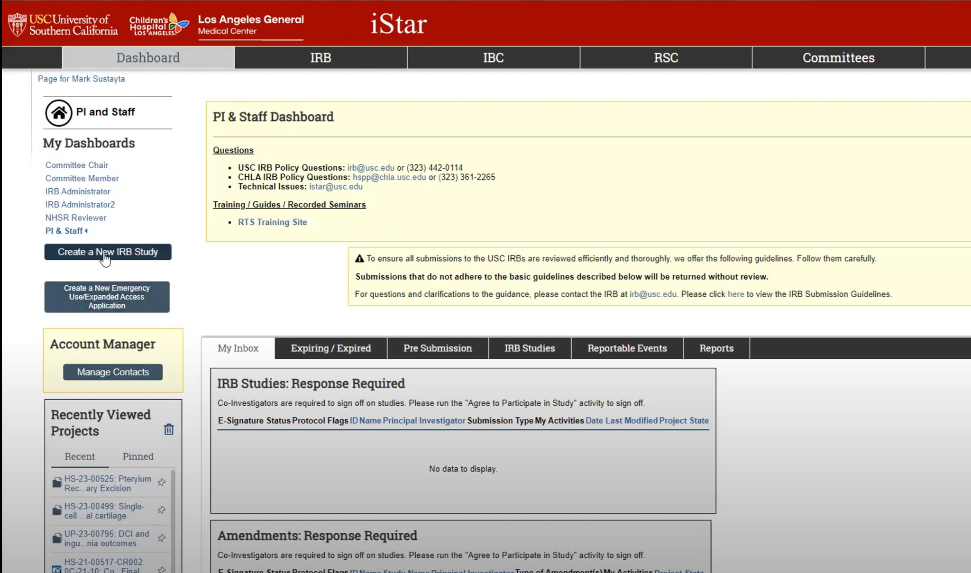

Section 1: Project Identification and Abstract

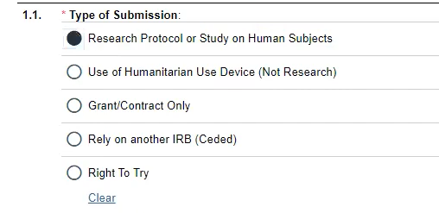

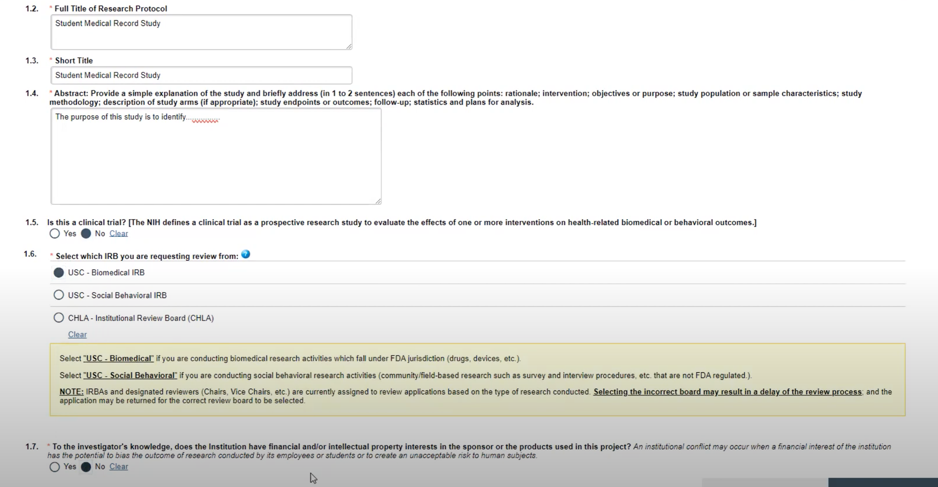
Pro Tip: In section 1.4 please address all of the points listed as applicable. Please note that there should not be an intervention nor follow-up since there will be no interaction with human participants and records only.

Section 2. Study Personnel

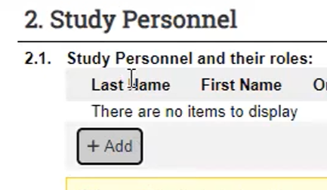
Add your name as PI.

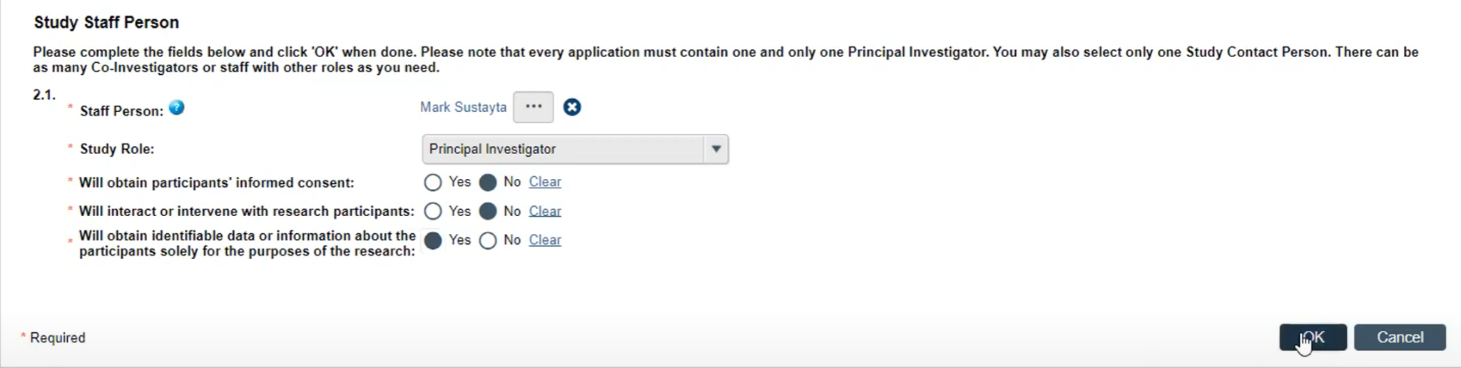

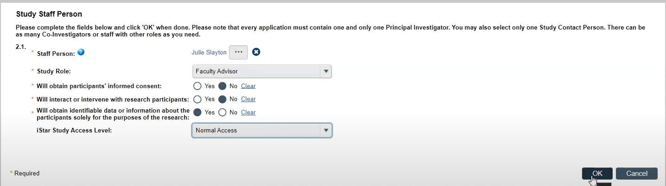
Faculty advisor will be chosen next.

Section 2.2 & 2.5

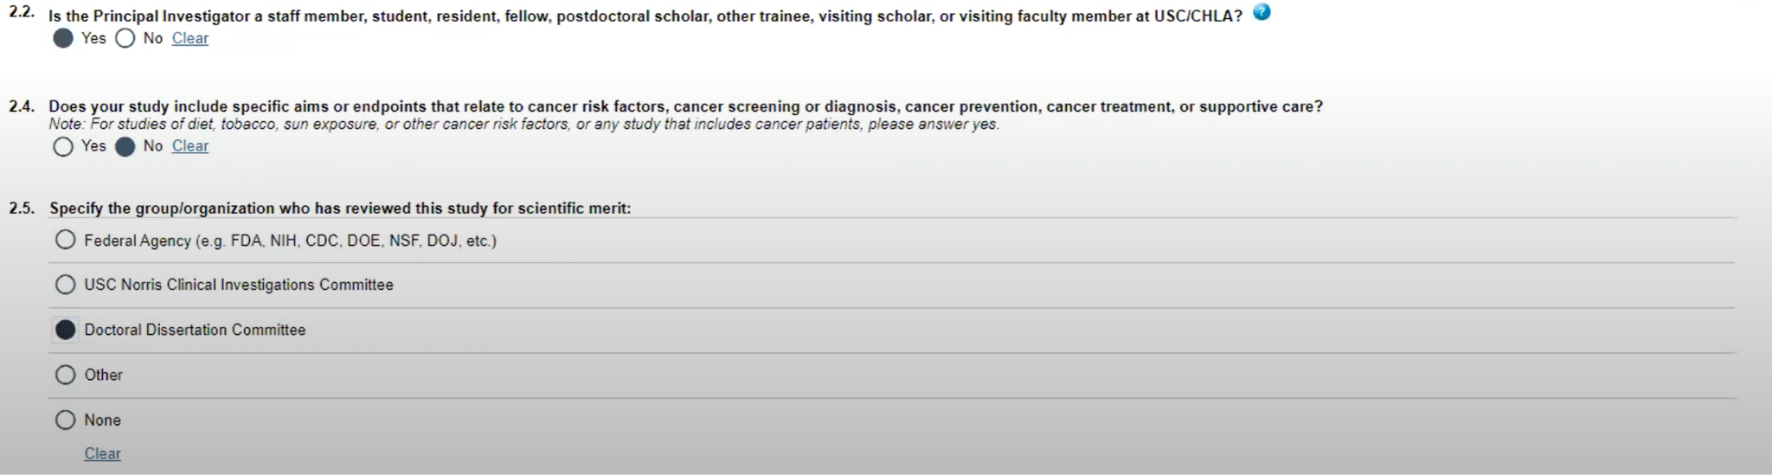
If you are doing student research, you will chose “Doctoral Dissertation Committee”.

Section 4: Funding
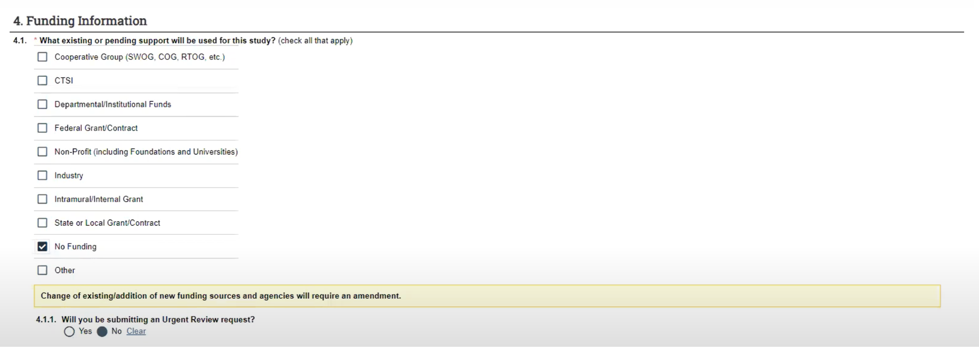
Most students do not have funding. Please carefully review the questions and make the appropriate choice.

Section 5: Type of Study Review

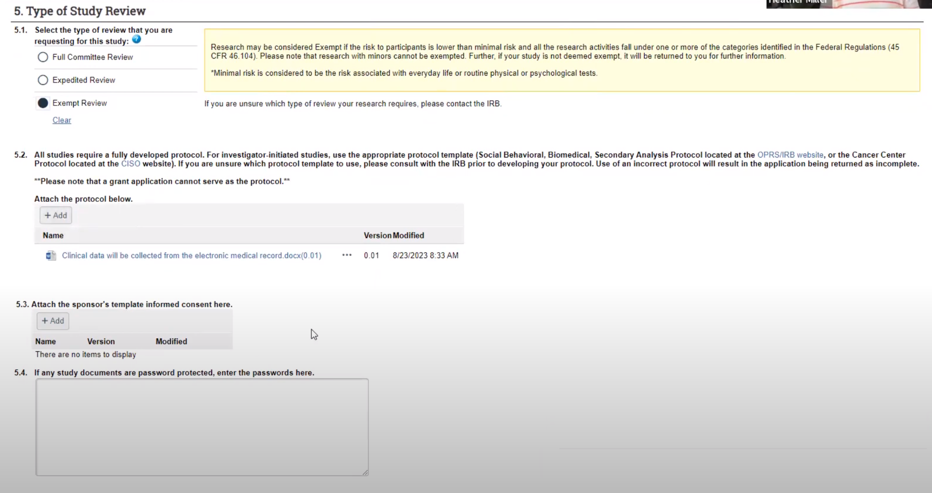
Pro Tip: Since you do not usually have a sponsor for student research you do not need to attach anything to 5.3.
You will be able to determine your “level of review” by reviewing this information on the website. Most student research is “exempt.”

Please add your protocol to section 5.2. You will find the protocol for medical records and specimens on the HRPP website.

Section 6: Study Locations

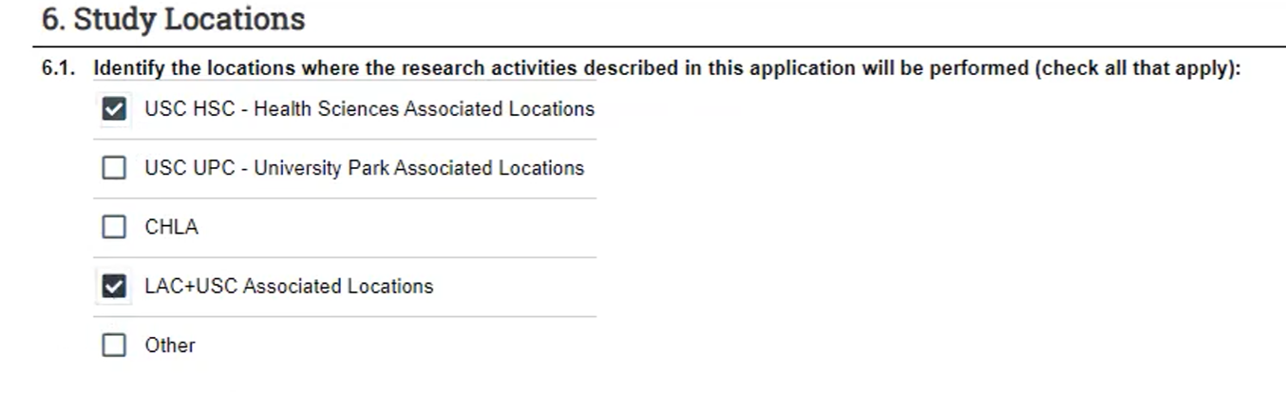
Please chose all applicable sites.

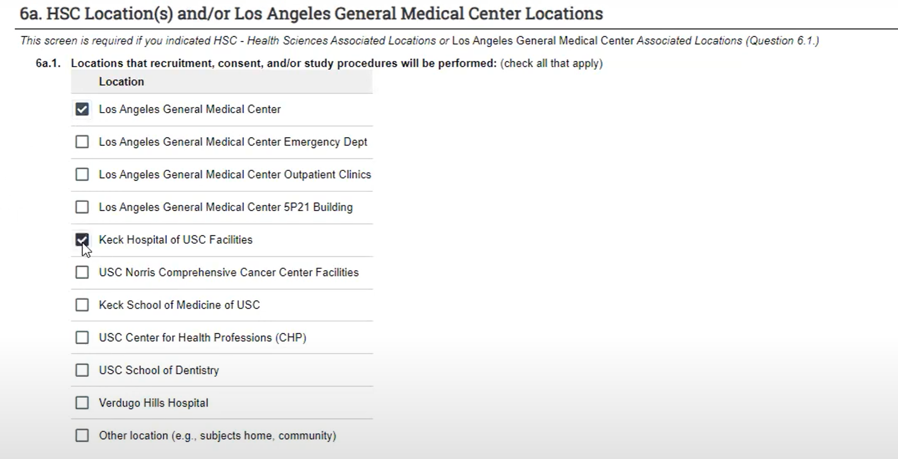
Depending on what you chose above, additional options will ‘pop up’.
Pro Tip: If there is no ‘room’ you may leave 6a.2 blank.

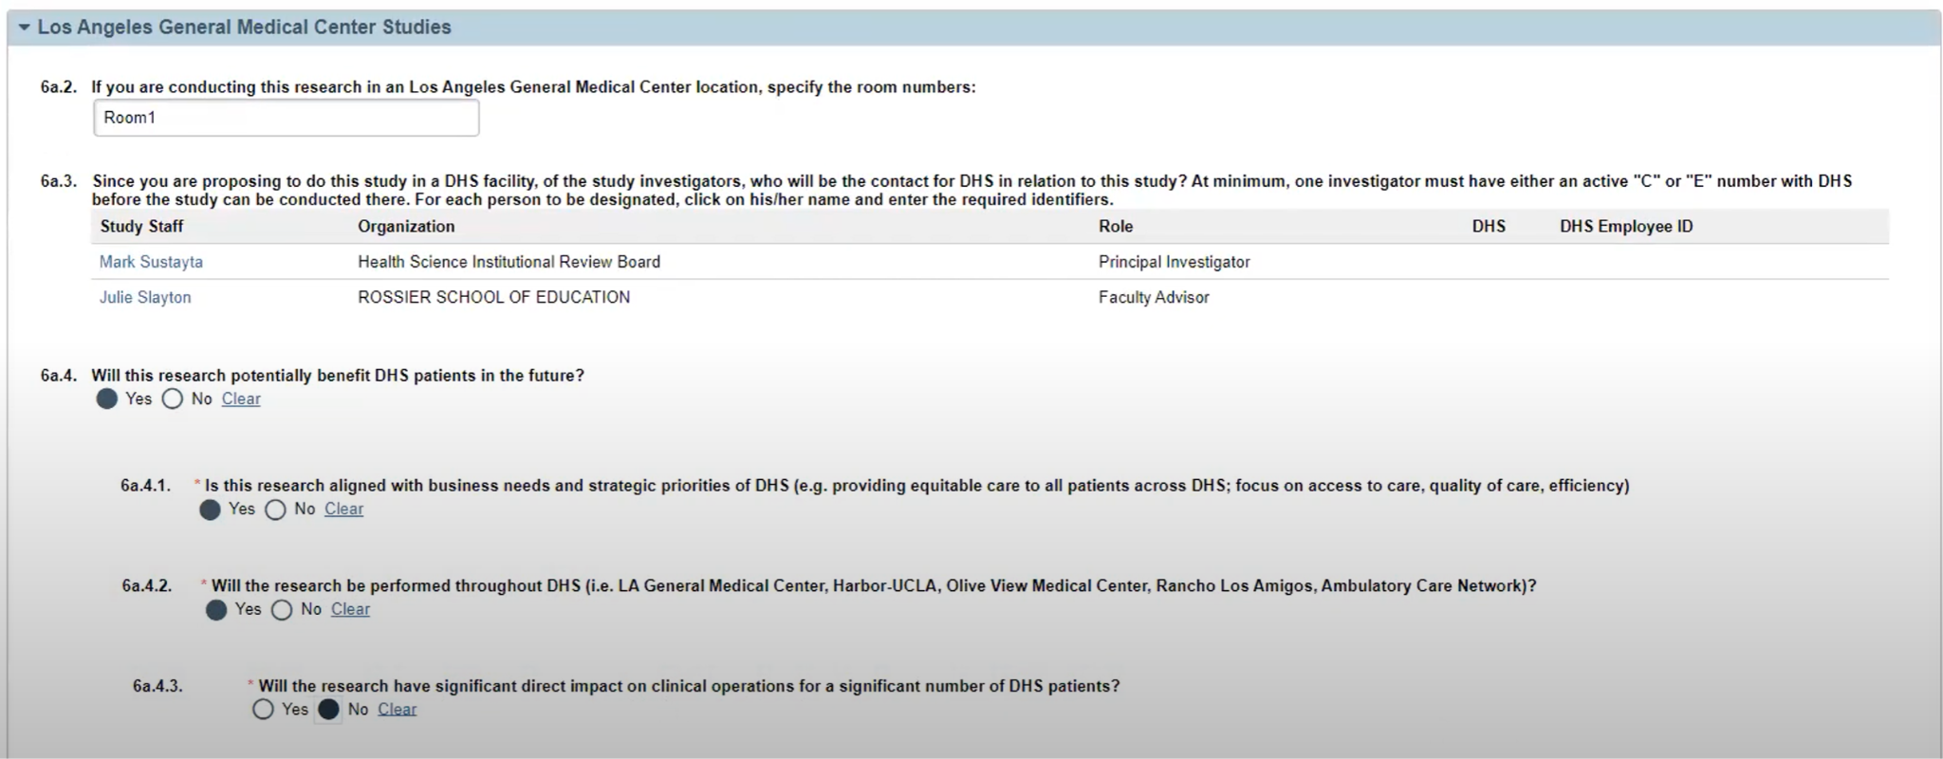
One investigator must have “C” or “E” number. This is usually the faculty.
6a.4 – 6a.4.3 -Please chose as notated above.

Section 9. Methods and Procedures

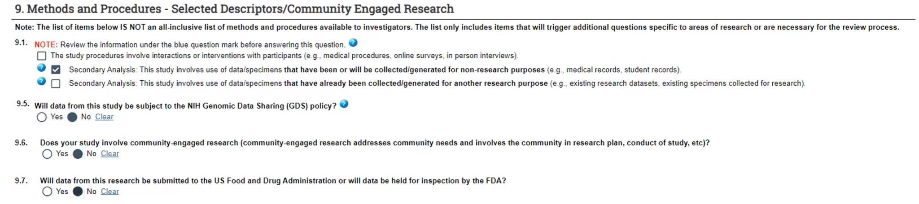
Please note that the box selection in 9.1 will generate additional options that will need to be addressed. See below. Please note that most student research is: Secondary Analysis: This study involves use of data/specimens that have been or will be collected/generated for non-research purposes.

Section 13. Methods and Procedures
Pro Tip: If you click yes in 13.1 please fill out the ‘certification request’, as it will be needed.
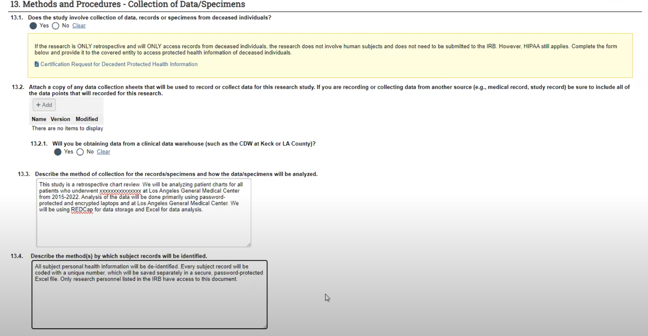
You do not need to attach anything to section 13.2.
Please answer 13.3 including what variables you are analyzing in the patient charts, and the timeline of data analysis.

Section 22. Special Subject Populations

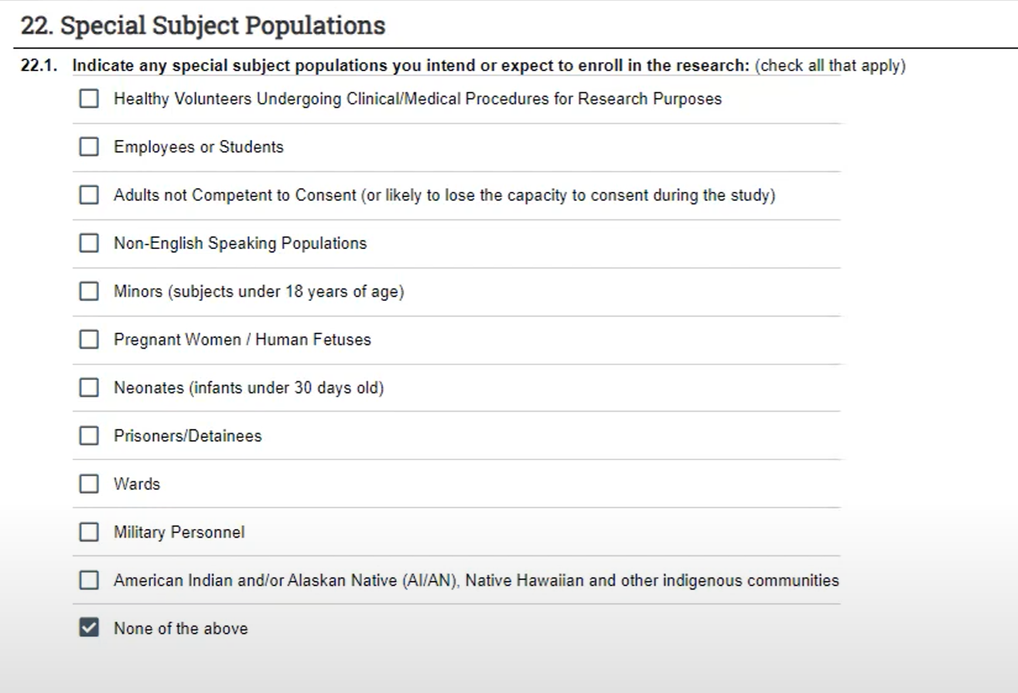
For patient charts/specimens only choose None of the above.

Section 26. Participant Privacy and Data Confidentiality

26.1

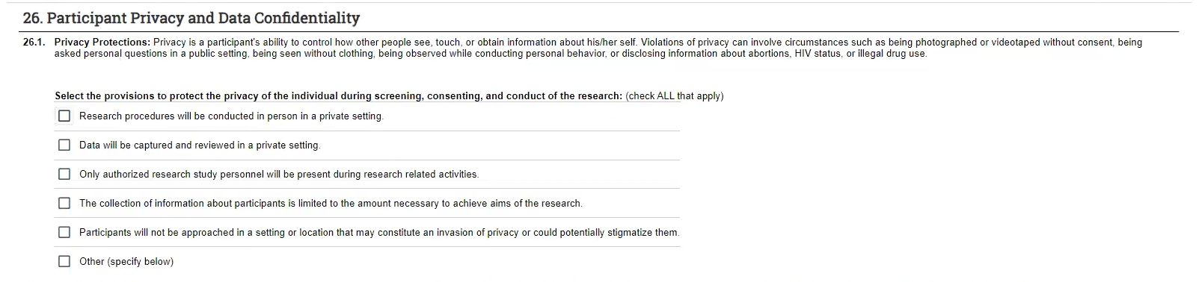
Select all that apply. Please carefully review and answer all applicable questions.
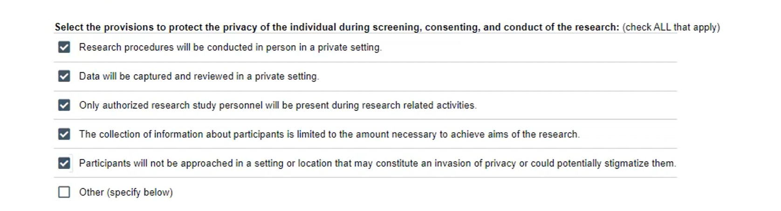

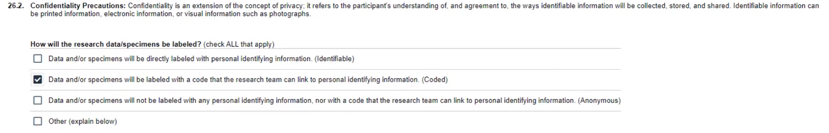

26.3

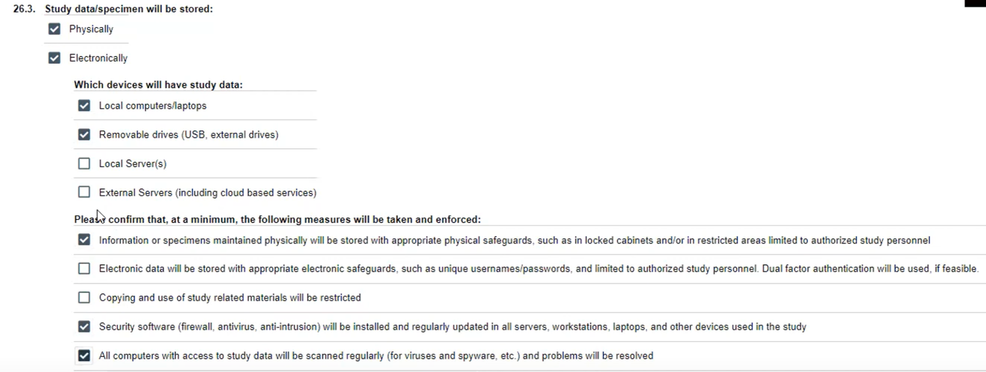
Please answer all questions and check all options as applicable.

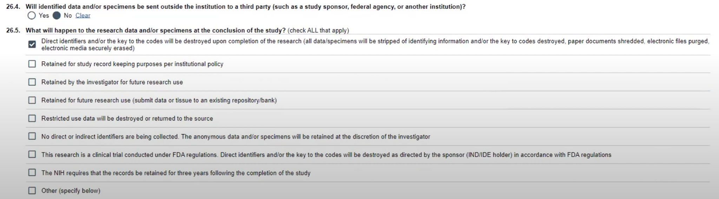

Section 35. HIPPA

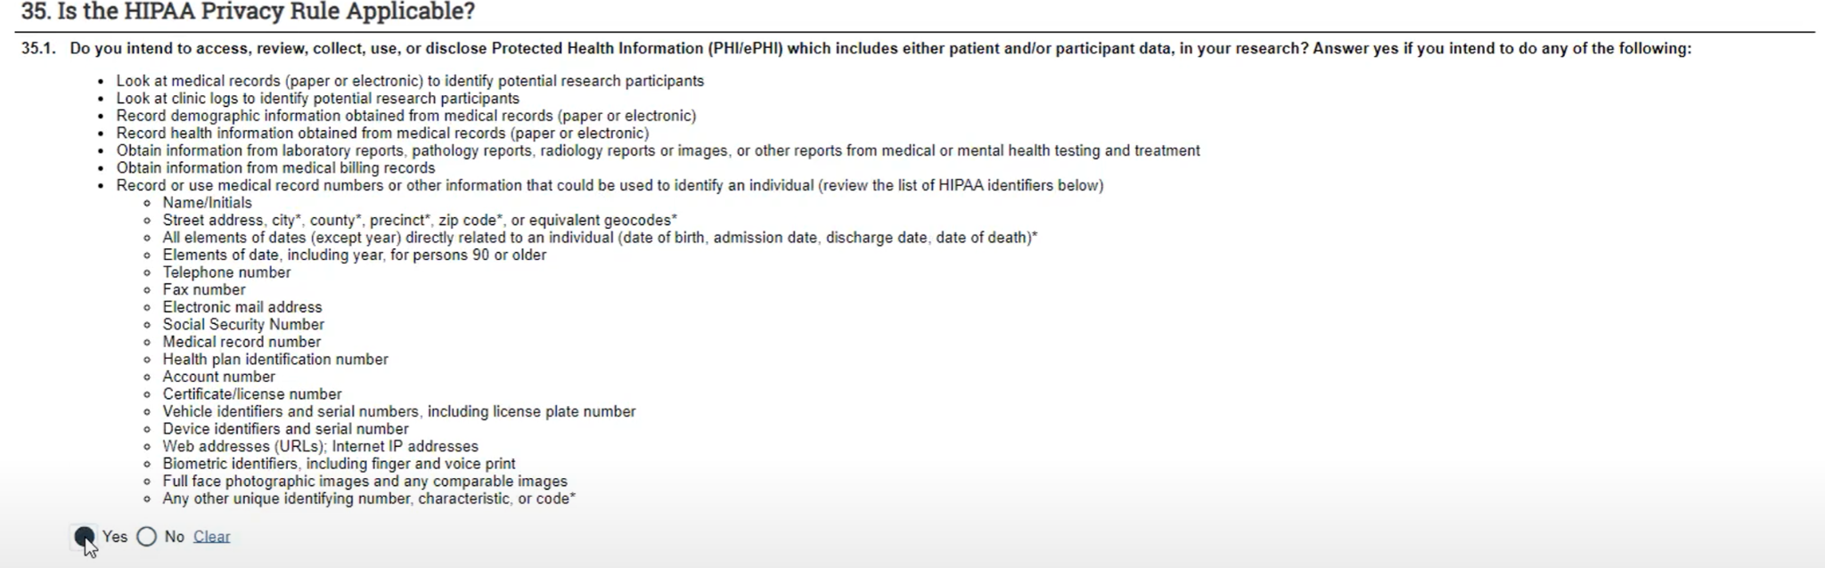

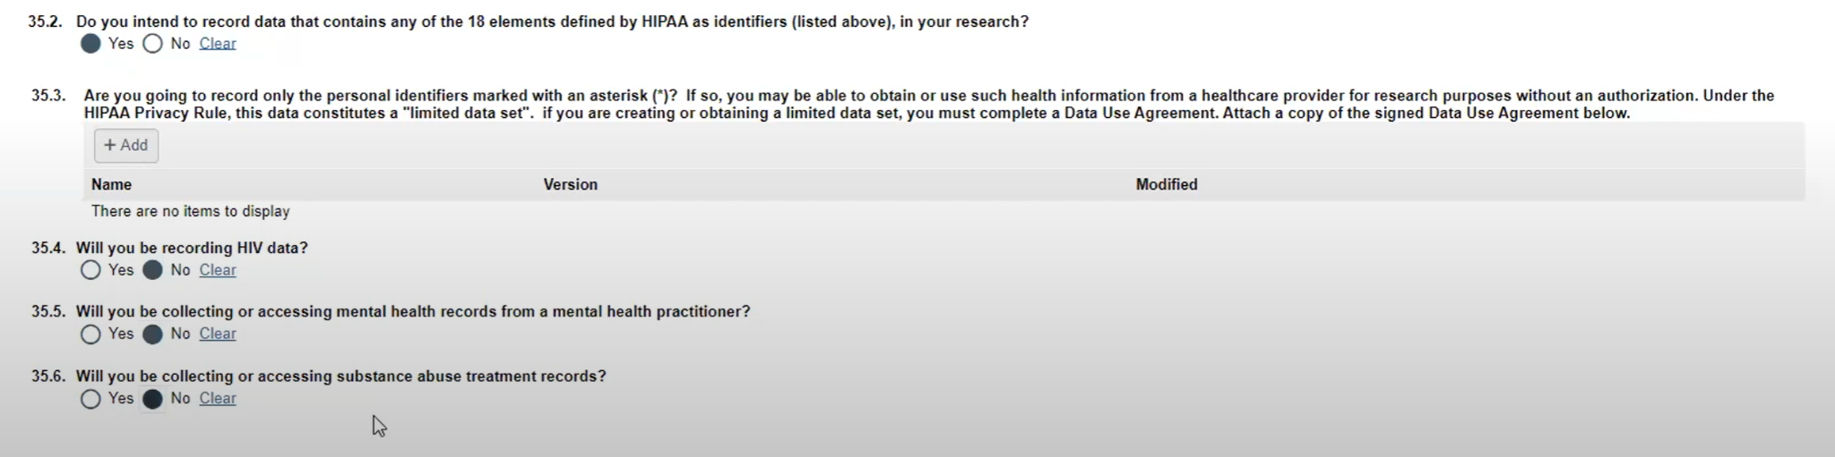
Pro Tip: You do not need to attach anything to 35.3.

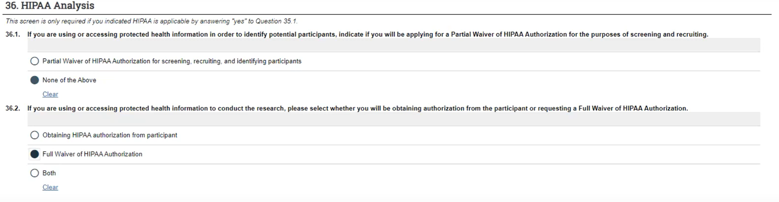
Please note that since you are looking at medical records or specimens, you will ask for a Full Waiver of HIPPA Authorization.

Section 37. Decedent Research
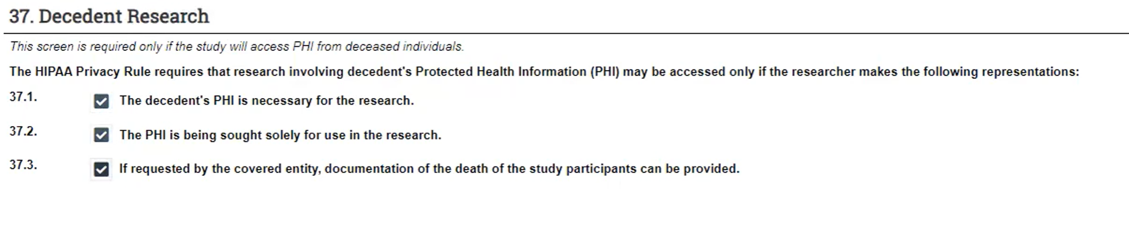
This section has populated because earlier (section 13) we chose “yes”.

Section 38.
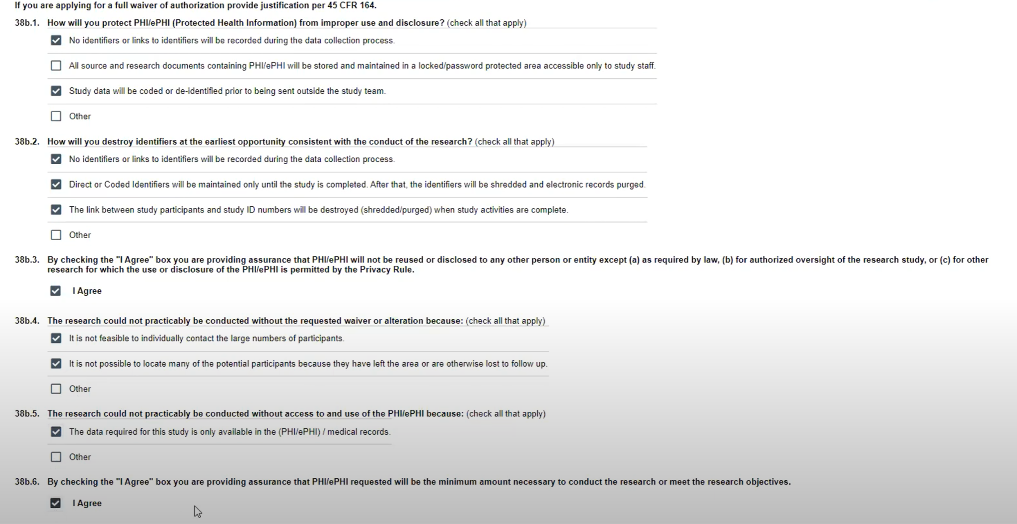
This section populates because “Full HIPPA Waiver” was chosen. Please carefully review choices.

Section 39. Conflict of Interest Information
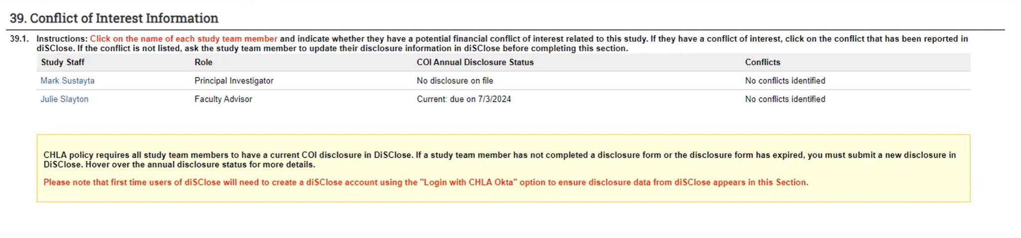

Section 40. Additional Supporting Documents
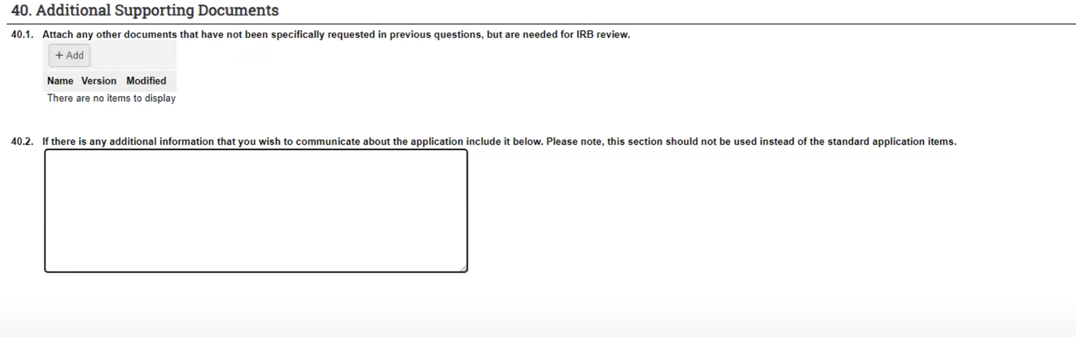
If you have decedent information (the Certification Request), please attach it to section 40.1.

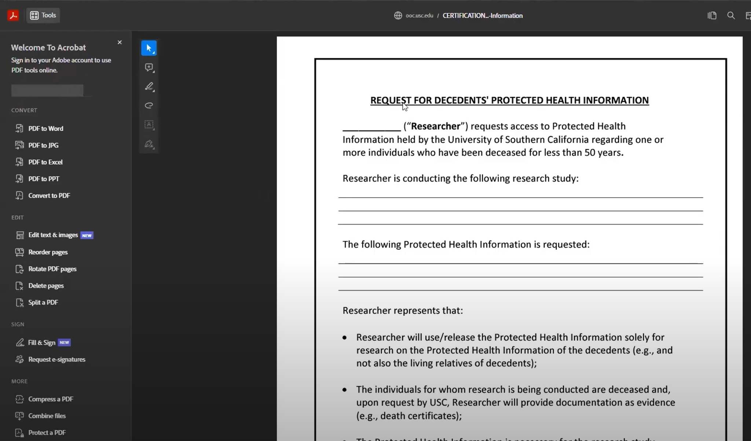
Certification Form Example: (if necessary, see Step 13), that will be uploaded to 40.1.

Section 42: Clinical Data Warehouse

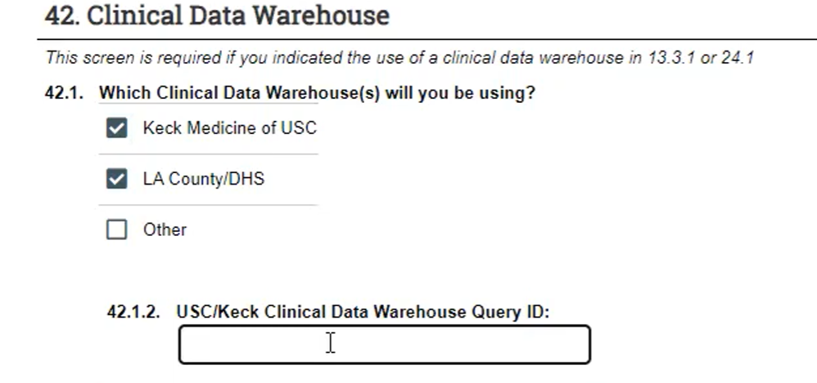
This section is populated because of the prior selections made in section 13.
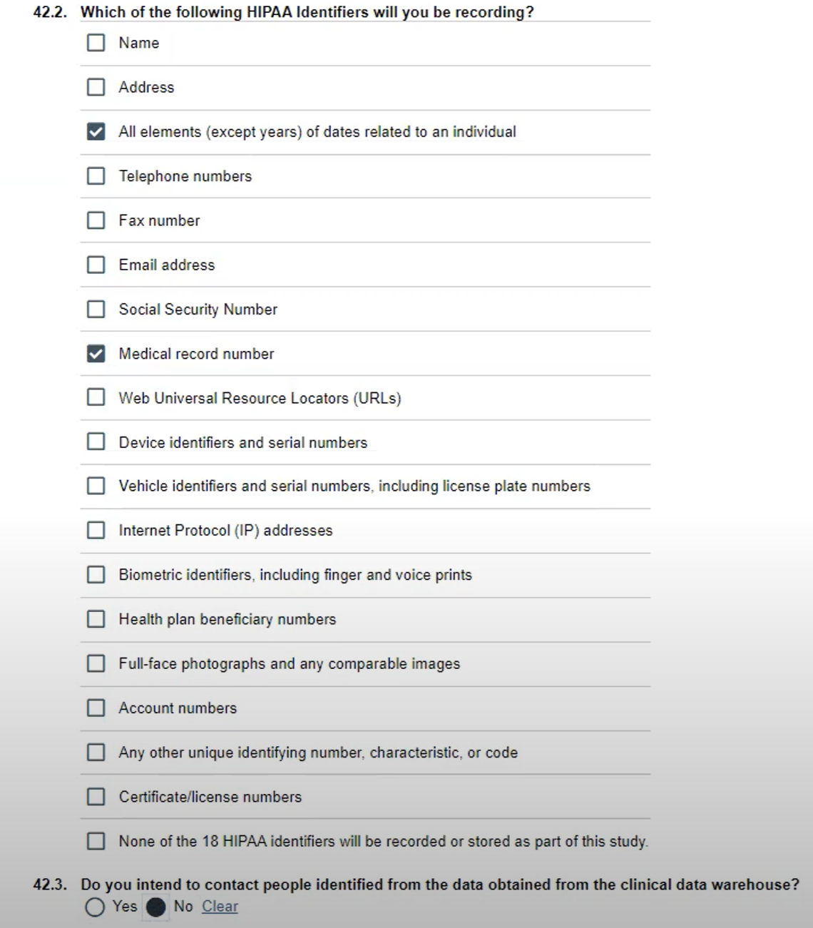
Please check all boxes applicable to you study.

Section 50. Required Approvals
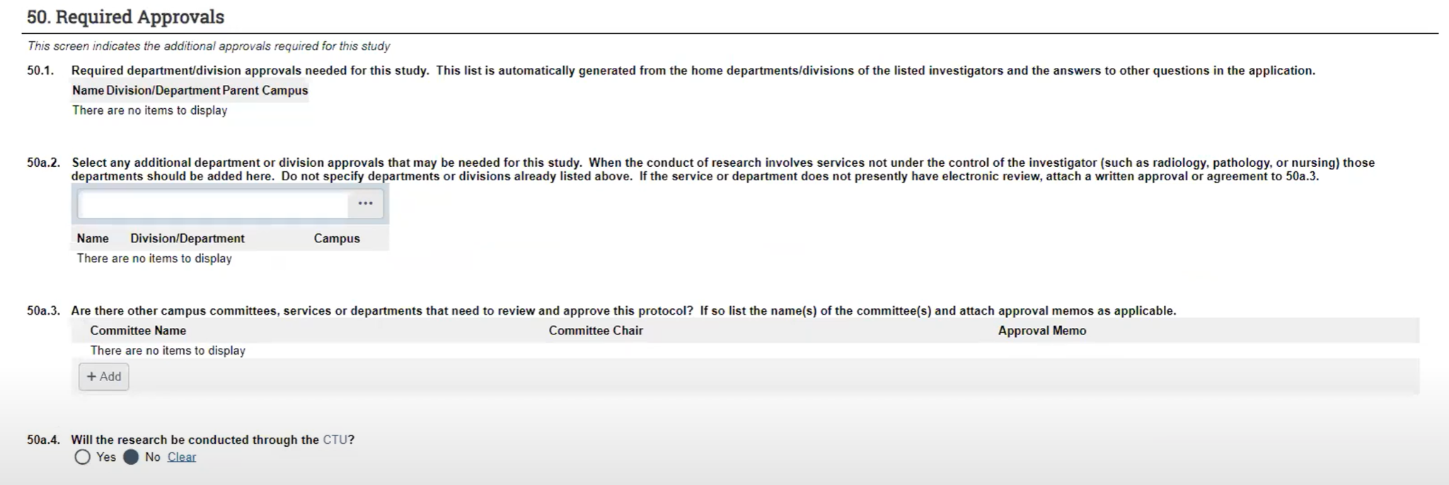
Please fill out 50a.2 as applicable; it is often blank for student researchers.

Section 99. Submit
